**NAMING RULES:**

**1**.Do use PascalCasing for class names and method names

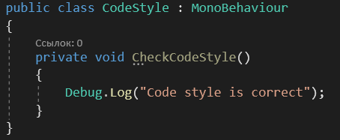

**2**.Do use camelCasing for method arguments and local variables

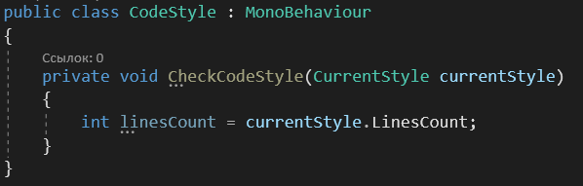

**3**.Do not use Hungarian notation or any other type identification in identifiers

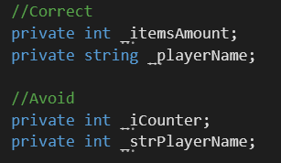

**4**.Do not use Screaming Caps for constants or readonly variables, name it in same way with common fields, but always with the first letter in uppercase

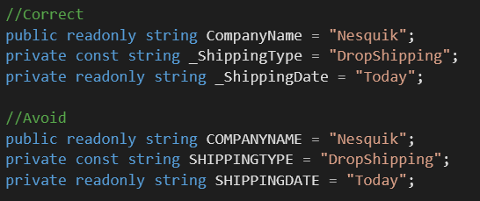

**5**.Avoid using Abbreviations. Exceptions: abbreviations commonly used as names, such as Id, Xml, Ftp, Uri.

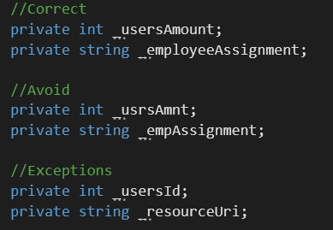

**6**.Do use PascalCasing for abbreviations 3 characters or more (2 chars are both uppercase)

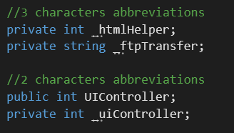

**7**.Do not use Underscores in identifiers. Exception: prefix private fields with an underscore

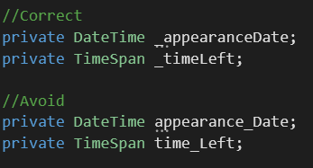

**8**.Avoid of using public fields, better to use properties

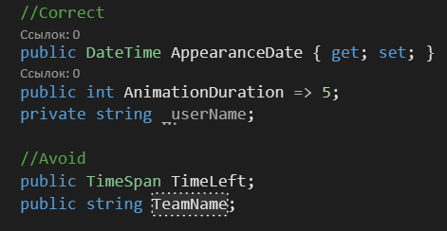

**9**.Do use implicit type var for local variable declarations when it use word new or Factory Method . Exception: primitive types (int, string, double, etc) use predefined names

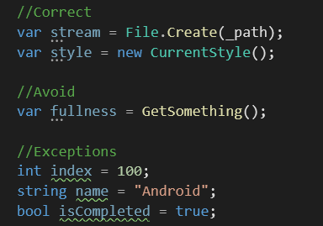

**10**.Do use noun or noun phrases to name a class

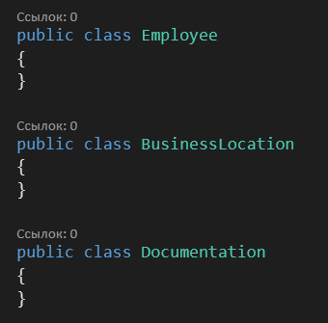

**11**.Do prefix interfaces with the letter I. Interface names are noun (phrases) or adjectives.

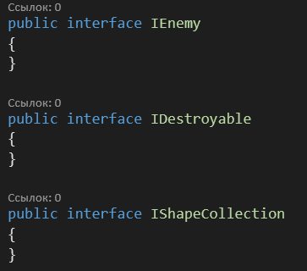

**12**.Do name source files according to their main classes.

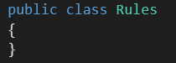

**13**.Do not use partial classes.

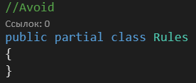

**14**.Do organize namespaces with a clearly defined structure

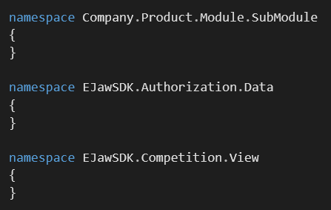

**15**.Do vertically align curly brackets

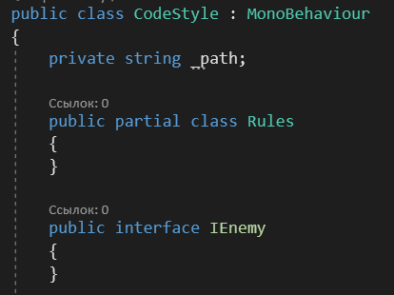

**16**.Do put the curly braces on a separate line. Here's a sample

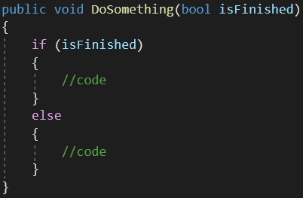

**17**.Do add the curly braces even if you have only one line run.

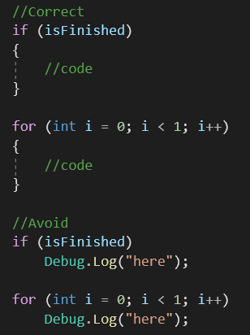

**18**. Group the code blocks by logic, separating them from the rest with an empty line

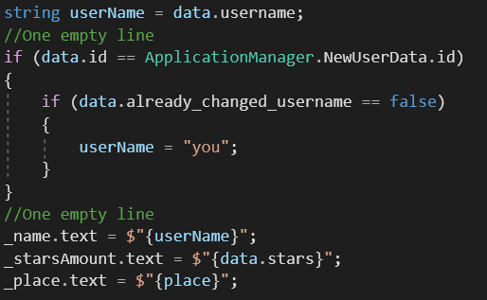

**19**. Group fields by access modifiers

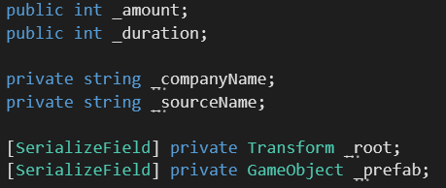

**20**. Separate methods with an empty line

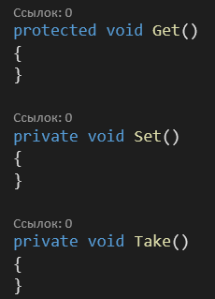

**21**. One file - one class

**22**.Sort by access modifiers public events ,public, internal, protected, private, [SerializeField] private, constructors, properties

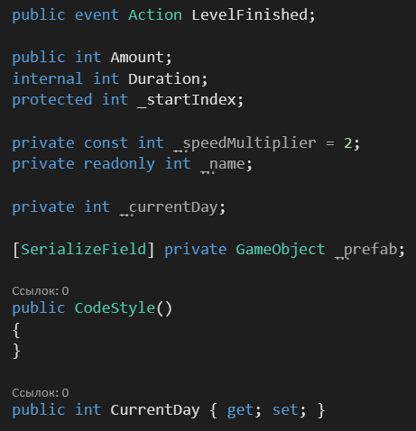

**23**.Do not create names of parameters in methods (or constructors) which differ only by the register:

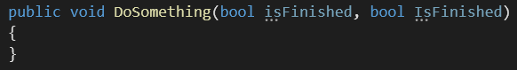

**24**.Do use suffix Exception at creation of the new classes comprising the information on exception:

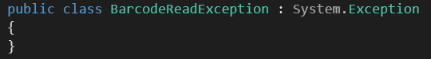

**25**.Events naming rules:

**-1.**Do name events with a verb or a verb phrase.

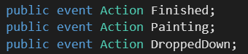

**-2.Do NOT use "Before" or "After" prefixes or postfixes to indicate pre- and post-events. Use present and past tenses as just described.**

**3.Do give events names with a concept of before and after, using the present and past tenses.**



**26**.Do use prefix On when handle event

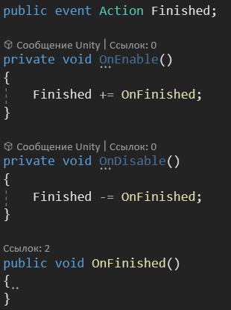

**27**.Delete all unused code and usings, use usings sorting

**28**.Explicitly specify access modifiers

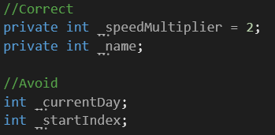

**29**.Save comments ONLY if you will need it later, otherwise delete it. Your code should be self - documented

**30**. Use sealed if class will not be inherited

**31**. Do use prefix On and postfix Click when handle button click event

